Activation Report
ASAP 7.0.2 – WASS1133, JAMU66
ASAP-ORIGIN

September 10th, 2018

Contents

1 Activation Orders: JAMU66 Originated by CIS 3
1.1 JAMU66 Service Orders 3
1.2 Activation Orders Origin Distribution 4
2 Activation Orders: WASS1133 Originated by CIS 5
2.1 WASS1133 Service Orders 5
2.2 Activation Orders Origin Distribution 6

Activation Orders: JAMU66 Originated by CIS

JAMU66 Service Orders

ORIGINATING CIS | TOTAL | PERCENTAGE | COMPLETE | FAILED | TIMEOUT
CIS_JAMAICA | 47156 | 74.93% | 35754 | 10978 | 424
CIS_CAYMAN | 2344 | 3.72% | 2109 | 235 | 0
CIS_ANTIGUA | 2575 | 4.09% | 2507 | 68 | 0
CIS_ANGUILLA | 529 | 0.84% | 524 | 5 | 0
CIS_BARBADOS | 1149 | 1.83% | 1129 | 20 | 0
CIS_BVI | 869 | 1.38% | 867 | 2 | 0
CIS_DOMINICA | 1301 | 2.07% | 1279 | 22 | 0
CIS_GRENADA | 770 | 1.22% | 770 | 0 | 0
CIS_MNI | 97 | 0.15% | 84 | 13 | 0
CIS_SANTA_LUCIA | 2362 | 3.75% | 2348 | 14 | 0
CIS_ST_KITTS | 694 | 1.10% | 690 | 4 | 0
CIS_SN_VINCENT | 798 | 1.27% | 797 | 1 | 0
CIS_TKI | 2118 | 3.37% | 1961 | 157 | 0
OCA | 157 | 0.25% | 134 | 23 | 0
INTEGSSOFT | 0 | 0.00% | 0 | 0 | 0
CIS_172_21_64_99 | 16 | 0.03% | 11 | 5 | 0
ASAP TEST | 0 | 0.00% | 0 | 0 | 0
 | 62935 |  | 50964 | 11547 | 424

Activation Orders Origin Distribution

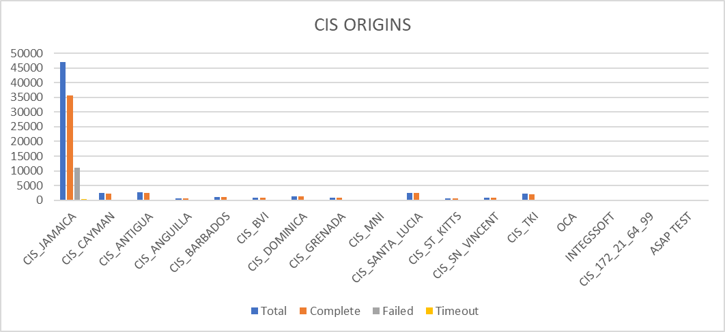

Activation Orders: WASS1133 Originated by CIS

WASS1133 Service Orders

ORIGINATING CIS | TOTAL | PERCENTAGE | COMPLETE | FAILED | TIMEOUT
CIS_JAMAICA | 18339 | 73.49% | 13909 | 2640 | 1790
CIS_CAYMAN | 0 | 0.00% | 0 | 0 | 0
CIS_ANTIGUA | 49 | 0.20% | 7 | 42 | 0
CIS_ANGUILLA | 220 | 0.88% | 171 | 49 | 0
CIS_BARBADOS | 0 | 0.00% | 0 | 0 | 0
CIS_BVI | 252 | 1.01% | 101 | 151 | 0
CIS_DOMINICA | 698 | 2.80% | 599 | 99 | 0
CIS_GRENADA | 937 | 3.75% | 858 | 79 | 0
CIS_MNI | 29 | 0.12% | 23 | 6 | 0
CIS_SANTA_LUCIA | 3488 | 13.98% | 3413 | 11 | 64
CIS_ST_KITTS | 292 | 1.17% | 251 | 41 | 0
CIS_SN_VINCENT | 402 | 1.61% | 363 | 39 | 0
CIS_TKI | 246 | 0.99% | 187 | 59 | 0
OCA | 2 | 0.01% | 0 | 2 | 0
INTEGSSOFT | 0 | 0.00% | 0 | 0 | 0
CIS_172_21_64_99 | 0 | 0.00% | 0 | 0 | 0
ASAP TEST | 0 | 0.00% | 0 | 0 | 0
 | 24954 |  | 19882 | 3218 | 1854

Activation Orders Origin Distribution

